**Shell Script Assignment**

Mandatory:

1. Create a script named “myscript” in current directory to do the following.

* To create a script named “myscript” in current directory use the “touch” command.

1. display “hello user”

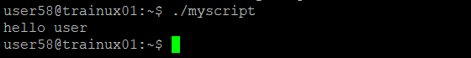

b) list files in current directory

To list files in the directory using the command “ll”.

c) name of logged in user

The name of logged in user, use this command “$whoami”

d) date

To display the date using command “$date”.

2. Add execute permission and Run the script from

a) current directory

To add execute permission use “chmod 0766 myscript” and run the script use ./myscript.

3. Create a subdirectory named “test”

To create a subdirectory names test “mkdir test” is used.

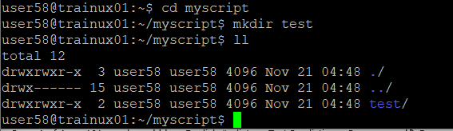

4. Change to “test” directory. Run the script “myscript” [Hint: You will have to update PATH to include the directory containg script to run script from any location].

To change to test directory and execute the myscript the commands used are:

>>cd test

>>export PATH=$PATH:$ (pwd)/..

>>myscript.sh